Web Function

Summary

Web function (WF) is a simple technology, which allows any client to execute a function remotely on a web server and return the result back to the client over HTTP.
Few usage examples:
- By using Web function you will be able to execute a database call and return the result back over the port 80, thus by passing the firewall problems.
- Web Function allows exposing standard methods or services, which can be used by any client.
- Perform custom messaging services like pop up a small message box on the client machine once the reports have been updated on the server.
- What ever you can think of?

Technologies Used
Visual Basic, VB Script, ASP, Database (Access), and IIS.

How It Works

I
N
T
E
R
N
E
T
Database

IIS Server

WF Client
(VB)

WF Server
(ASP, VB Script)

The WF Client makes a Web function call over HTTP protocol. The web function is then executed over the web server and the result is then returned back through the wire back to the client. The VB Client then parses the return values and displays the result.

The WF Client is using the Microsoft Internet Transfer Control (Inet) to communicate with the Web Server. Each Web Function is implemented by using an ASP Page (WF Server). If the Web Function accepts any parameters, then those parameters will be passed to the ASP Page using the Inet Control. The ASP page will execute on the web server and if it has to return any value then it will perform a Response.Write(). The result is captured by the Inet control (the return value for your web function). If you have to return multiple values then you can separate them by commas when you do the Response.Write() and then parse the full string into the multiple result sets.

I have 2 examples to explain this concept
- A Simple HELLO WORLD Web Function
- A Complex Database Web Function, where we are going to built a simple login form where the user enters the username and password which will be validated by calling a web function which will look up in the database table and return a Boolean value. Once validated another web function will populate a combo box with his selected Stock Symbols from another database table.
Note: There is a constant in the WFClient.WebFunction form module which is:
Const WFLocation = "http://www.xSolveNet.com/Articles/WebFunction/WFServer/”. This location will work, but if you are setting up your own WF Server then you need to point it to you web location for the WebFunction Folder.

HELLO WORLD Application

Steps for the WF Server:
- Create a ASP Page and name it WF_HelloWorld.asp
- In this page add the following code
<%@ Language=VBScript %>
<% Option Explicit %>
<% Response.Write (“Hello World”) %>
- Create a folder called WebFunction under InetPub/wwwroot on your web server.
- Copy the file WF_HelloWorld.asp to this folder.
- Open the asp file in a web browser and make sure you get to see the string “Hello World”.

Steps to set up the WF Client:
- Run the WFClient Application.
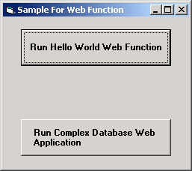

- Click on the first button. After a small duration you will see a message box pop up saying “Hello World”
- There is a main Form Module, which is called the WebFunction, which handles all the communication with the Web Server.
- The HelloFunction is called by setting up the correct URL
Public Function HelloWorld() As String

WFName = "WF_HelloWorld.asp"
HelloWorld = RunWebFunction(WFName)

End Function
- RunWebFunction sets the URL property for the Inet control and then the Open method is called which then calls the ASP page. The ASP page is executed on the web server, which writes the String “HELLO WORLD”. This string is the return value for the Inet’s Open method.
Public Function RunWebFunction(ByVal URL As String) As String
Inet.URL = WFLocation & URL
RunWebFunction = Inet.OpenURL
End Function

Database Web Function Application

Steps to set up the Database WF Server
- In the same Web Folder (WebFunction) copy the Access Database called WFDemo.mdb
- Create a System DSN called WFDemo.
- In the Global.asa add a application variable
Application("WFDemo_ConnectionString") = "DSN=WFDemo"
- Copy the WF_ValidateUser.asp and the WF_GetStockSymbol.asp to the same folder.
- Open the ASP Page in a browser and verify they are working properly by passing it the correct arguments
- Test the WF_ValidateUser Page: http://<server-name>/WebFunction/WF_ValidateUser.asp?UserName=john&Password=john
- It will return “TRUE”
- Test the WF_GetStockSymbol Page: http://<server-name>/WebFunction/WF_GetStockSymbol.asp?UserName=john
- It will return: MSFT,INTC,AMZN,YHOO,CSCO,VITR
- Also make sure you have anonymous access set on the web folder. (Use IIS to set up the security).

Run the WFClient and click on the second button, the following screen will be displayed:

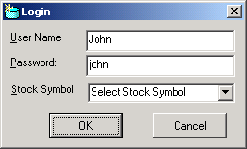

Click “OK” and the username and password will get validated by calling the Web Function WF_ValidateUser.asp. Once validated you will be displayed a Message box.

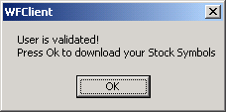

Click OK, and another Web Function will download all the stock symbols, and will load the Stock Symbol Combo Box.

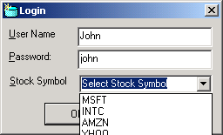

Conclusion
Web Services, which is implemented in VS.Net, does something very similar. My version is a scaled down version of Web Services. It is not using SOAP or XML. XML can be used for formatting the result and then WF Client can parse it to extract the results.

I am using this technology to develop a client server application, which will publish your machines local IP address to a centralized web server. You can access your local Machine IP address from anywhere and then connect to your machine using pcAnywhere or host a FTP Site or a Web site. This will allows people to host their website or FTP site on their home machine with dynamically assigned IP.

